Introduction
Restaurant deliveries have been significantly increased during and after the Covid-19 pandemic. This increased demand and insufficient delivery resources has made the restaurants to join with online food delivery(OFD) platforms or initiate self-logistics inside the restaurant for delivery operations [1]. But the restaurant needs to understand how the delivery demand variation from time to time to provide a better service to earn and develop the customer satisfaction. To identify the delivery demand more accurately, restaurant should divide the deliveries into different zones. Most industries have already segregated their service area into zones to provide a better service and for route optimization [2] indicates that restaurant can use the same strategy. Traditional restaurant will use the milestones in the city and memorize them. Technology integrated restaurants will use the coordinate ranges saved in the system and system will allocate the delivery location for the relevant zone. But these methods have become outdated with the improvement of AI. Using unsupervised machine learning algorithm such as clustering, restaurants can identify the different zones using past deliveries more efficiently and even check whether the zones divided previously created without AI are actually feasible for the restaurant.
Clustering has gained significant attention for the uses of market segmentation, social network analysis, medical imaging etc in the current context. Different clustering algorithm is used for each use case. There are four different clustering algorithm types: 1) Centroid-based clustering 2) Density-based clustering 3) Hierarchical clustering 4) Distribution-based clustering [3]. Many clustering algorithms are falling to these 4 types. But for segregation of delivery locations to zones, best algorithm should be determined out of all the 4 types and algorithms. Not much research has been conducted on this concern, even for different industry delivery components. Through this paper, we are focusing on answering the research question “What is the best clustering algorithm for segregating delivery locations into different zones?”.
The remainder of the paper is organized as follows: Section 2 reviews the current literature on restaurant systems and clustering methods. Section 3 describes the data generation process, analysis, and the implementation of the algorithms. Section 4 presents the results, while Section 5 discusses the findings, future research applications and concludes the paper.

Literature Review
Clustering is used widely around the world for many applications. Much research has been done for various industries such as electronics, healthcare, energy, geological etc. [4] has explored literature on how clustering can be useful for fault detection and fault classification with type of fault be analysed through different clustering algorithms such as K-Means, K-medoids, Hierarchical Clustering etc. [5] explains how Gaussian Mixture clustering be useful in the PI-ICR data analysis in nuclear physics. [6] has used eleven different clustering algorithms for their analysis to see which performs better on smart meters time series data. [7] used K-Means, Agglomerative, DBSCAN and Spectral algorithms for their analysis on medical image clustering. [8] analysed how clustering algorithms for various preprocessing tasks of MRI for diagnosis of Alzheimer disease, mild cognitive disorder, and other types of dementia. Next, we focused on research which clustering has been done on logistics and locations. [9] reviews how clustering is impacted to geospatial analysis by analysing different clustering algorithms and evaluation metrics. Using a Customized K-Means algorithm approach [2] has explored of finding optimal locations for existing EV charging stations to give easy access and convenience for EV charging consumers. [10] used K-Means algorithm on coordinates to optimal locations of viewports in Seoul for personal air vehicles(PAV).
Analysing these literature shows that restaurants can use clustering for delivery locations but the best algorithm to do the task needs to be determined.

Research Methodology
In the methodology, we discuss on how the dataset be generated, what clustering algorithms be using and the evaluation metrics of the clustering result in this benchmark process for delivery locations.

Dataset generation
For the purposes of this analysis, a synthetic dataset with delivery locations is generated to represent a restaurant located in Manhattan, New York, United States. The locations will be used in clustering algorithms as input. We start by identifying 10 zones around this restaurant. For clarity, we assign a label for each zone which will be use in the latter part of the methodology.
Zone | Label
Financial District | 0
SoHo | 1
Chelsea | 2
Midtown | 3
Upper East Side | 4
Greenwich Village | 5
Gramercy | 6
Tribeca | 7
Hell's Kitchen | 8
Upper West Side | 9

Then we declare the zone range in coordinates(min/max latitudes and longitudes). Delivery location coordinates will be derived through random values coming from uniform distribution within each zone range. Through this, we create 400 deliveries(for a month) with delivery location coordinates distributed within the 10 zones.

Scaling for Normalization
Before moving on to the clustering, we need to scale our delivery location coordinates, because clustering algorithms are high computing processes. If the input contains large values as coordinates, clustering process will take a long time. In this approach, standard scaling is applied to normalize the feature scales, which facilitates improved convergence of the learning algorithm, particularly given the use of latitude and longitude as input features. Mathematically explained as below.
$$z=\frac{x- μ}{σ}$$

Where,
$x$ = original coordinates value
$μ$ = mean of the coordinates values
$σ$ = standard deviation of the coordinates values
$z$ = standardized coordinate value
The scaled coordinates will be the inputs to the clustering process for each algorithm discussed next.

Clustering using different algorithms
For this analysis, we need to select the relevant clustering algorithms that suits with our scenario. These algorithms were chosen on two conditions: 1) Distance between points should be the metric for the process; since we are working with delivery location coordinates and coordinates are considered with distance. 2) Number of clusters must be required as a parameter; clustering algorithm should provide the results according to the number of clusters we specify since restaurants will be deciding how much number of zones they going to maintain. So, the number of clusters will be considered as number of zones. Using these two conditions, we sorted out six clustering algorithms which distributed among the four clustering algorithm types: K-Means, Agglomerative, BIRCH, Mini-Batch K-Means, Spectral and Gaussian Mixture.

The K-Means algorithm, a centroid-based clustering method, separates data into n clusters by reducing within-cluster variance, starting with randomly selected centroids to which data points are assigned based on closeness. It iteratively updates centroids by calculating the mean of each cluster’s points until convergence, grouping similar data points together.
Agglomerative clustering, a hierarchical bottom-up approach, starts with each data point as a separate cluster and iteratively combines them based on a linkage criterion. Common criteria include Ward (minimizing within-cluster sum of squared distances), complete (minimizing maximum pairwise distance), average (minimizing average pairwise distance), and single (minimizing distance between closest observations).
BIRCH clustering is a hierarchical method that efficiently clusters large datasets by first creating a compact summary that preserves key information, then clustering this summary instead of the full dataset. Renowned for its incremental and dynamic clustering capabilities, BIRCH effectively handles multi-dimensional metric data points while optimizing memory and time resources.
Mini-batch K-means is a scalable variant of the conventional K-means clustering algorithm that processes small, randomly sampled subsets of data, called mini-batches, in each iteration to update cluster centroids. This approach substantially reduces computational cost and memory usage, enabling faster convergence on large datasets compared to the standard method.
Spectral clustering is a graph-based method that represents data samples as nodes and clusters them by solving a graph partitioning problem using the eigenvalues of a data similarity matrix. It is particularly effective for non-convex or complex cluster structures, such as nested circles in 2D, where traditional measures of cluster center and spread are inadequate.
Out of these six clustering algorithms, we are focusing on finding the best algorithms to segregate the delivery area of a restaurant into zones. For each model, we set the number of clusters to 10 as our chosen restaurant is handling 10 zones. We set threshold to 0.1 for BIRCH algorithm as we are dealing with location coordinates. Finally, we test each algorithm using scaled location coordinates and evaluate each algorithms performance using metrics explained in the next section.

Clustering Performance Evaluation Metrics
To evaluate clustering delivery zones using different algorithms, we use two types of metrics: 1) Internal metrics - These metrics rely solely on the data and clustering results, without requiring ground truth labels(actual labels) 2) External metrics – Metrics to compare clustering results to the ground truth(actual labels). We have the actual zones which the restaurant has segregated using coordinate ranges. Therefore, in this analysis, we can evaluate both internal and external metrics.
As Internal Metrics, we have chosen Silhouette Score, Davies-Bouldin Index and Calinski-Harabasz Index .
Silhouette Coefficient is defined for each sample and is composed of two scores:
$$s= \frac{b - a}{max(a, b)}$$
Where,
a = Mean distance between a sample and all other points in the same class.
b = Mean distance between a sample and all other points in the next nearest cluster.
Higher Silhouette Coefficient score relates to a model with better defined clusters.
Davies-Bouldin Index signifies the average ‘similarity’ between clusters, where the similarity is a measure that compares the distance between clusters with the size of the clusters themselves. A lower Davies-Bouldin index relates to a model with better separation between the clusters. Zero is the lowest possible score. Values closer to zero indicate a better clustering.
$$DB = \frac{1}{N} \sum_{i=1}^{N}{D_{i}}$$
Where,
$N$ = Number of samples,
$D_{i}$ = Distance between clusters with the size of the clusters(Conservation Approximation)
Calinski-Harabasz Index is the ratio of the sum of between-clusters dispersion and of within-cluster dispersion for all clusters (where dispersion is defined as the sum of distances squared). A higher Calinski-Harabasz score relates to a model with better defined clusters.
$$CH = \frac{B_{k }/(k - 1)}{W_{k }/(N - k)}$$
Where,
$N$ = Number of samples,
$B_{k }$ = Between group dispersion,
$W_{k }$ = Within-cluster dispersion
$k$ = Number of clusters.
Rand index, Adjusted Rand Index, Mutual Information, Adjusted Mutual Information, Normalized Mutual Information, Fowlkes-Mallows Index, Homogeneity, Completeness and V-measure is taken into evaluation as external metrics.
Rand Index measures the similarity of the two assignments, ignoring permutations. If C is a ground truth(actual labels) and K the clustering labels,
$$RI = \frac{a + b}{C_{2}^{n_{samples}}}$$
$a$ = Number of pairs of elements that are in the same set in C and in the same set in K
$b$ = Number of pairs of elements that are in different sets in C and in different sets in K
$C_{2}^{n_{samples}}$ = Total number of possible pairs in the dataset
However, the Rand index does not guarantee that random label assignments will get a value close to zero (especially if the number of clusters is in the same order of magnitude as the number of samples). To counter this effect, we can discount the expected RI $E\left[RI\right]$ of random labelling’s by defining the Adjusted Rand Index $ARI$ as follows,
$$ARI = \frac{RI - E\left[RI\right]}{max(RI) - E\left[RI\right]}$$
Mutual Information measures the agreement of the two assignments, ignoring permutations. Assume two label assignments $U, V$ (of the same N objects),
$$MI(U, V) = \sum_{i=1}^{\left|U\right|}{\sum_{j=1}^{\left|V\right|}{P(i, j)\log\left(\frac{P(i, j)}{P(i)P(j)}\right)}}$$
Normalized mutual information $NMI$ is defined as,
$$NMI = \frac{MI(U, V)}{mean(H(U), H(V))}$$
Where $H(U)$ and $H(V)$ entropy is the amount of uncertainty for each. (See Appendix for Equations)
Using the expected value, the adjusted mutual information can then be calculated using a similar form to that of the adjusted Rand Index $AMI$,
$$AMI = \frac{MI - E\left[MI\right]}{mean(H(U), H(V)) - E\left[MI\right] }$$
$RI$, $ARI$, $MI$, $NMI$, and $AMI$ can be used as consensus measures because swapping the arguments does not change the scores.
Fowlkes-Mallows index $FMI$ intends to measure the similarity between two clustering results. It is defined as the geometric mean of the pairwise precision and recall:
$$FMI = \frac{TP}{\sqrt{(TP+FP)(TP+FN)}}$$
Where,
$TP$ (True Positive) = Number of pairs of points that are clustered together both in the true labels and in the predicted labels,
$FP$ (False Positive) = Number of pairs of points that are clustered together in the predicted labels but not in the true labels,
$FN$ (False Negative) = Number of pairs of points that are clustered together in the true labels but not in the predicted labels.
Homogeneity score $h$ measures each cluster contains only members of a single class while completeness score $c$ measures all members of a given class are assigned to the same cluster. Their harmonic mean called V-measure $v$.
$$h = 1 - \frac{H(C|K)}{H(C)}$$
$$c= 1 - \frac{H(K|C)}{H(K)}$$
$$v = 2 × \frac{h × c}{h+ c }$$
$H(C|K)$ and $H(K|C)$ are the conditional entropy of the classes given the cluster assignments and conditional entropy of clusters given class. $H(C)$ and $H(K)$ are the entropy of the classes and entropy of clusters. (See Appendix for Equations)
Higher score for all external metrics is considered as best clustering.

Results
For the complete methodology, Python was used as the programming language to compute stated processes. Below python frameworks and modules were used for each process in the methodology.
Dataset generation – Numpy / Pandas
Clustering algorithms and evaluation metrics – Scikit-Learn [11]
Dataset generation was successful. We were able to create a dataset of 400 delivery locations and the zone they belong to. Figure 1 shows the number of deliveries per zone and Figure 2 shows the distribution of the delivery locations among the zones.
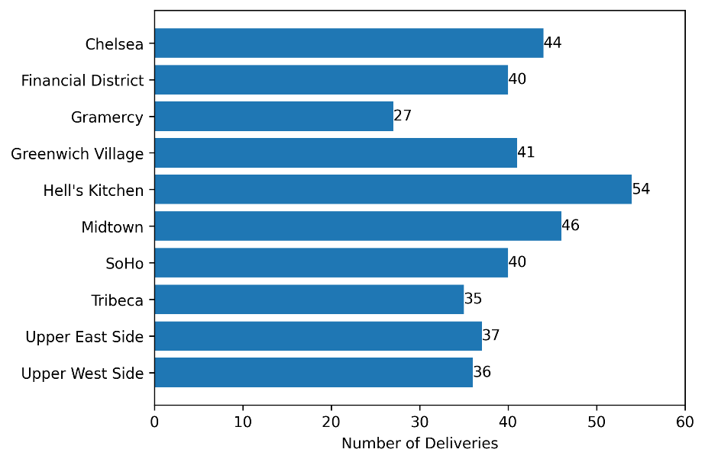
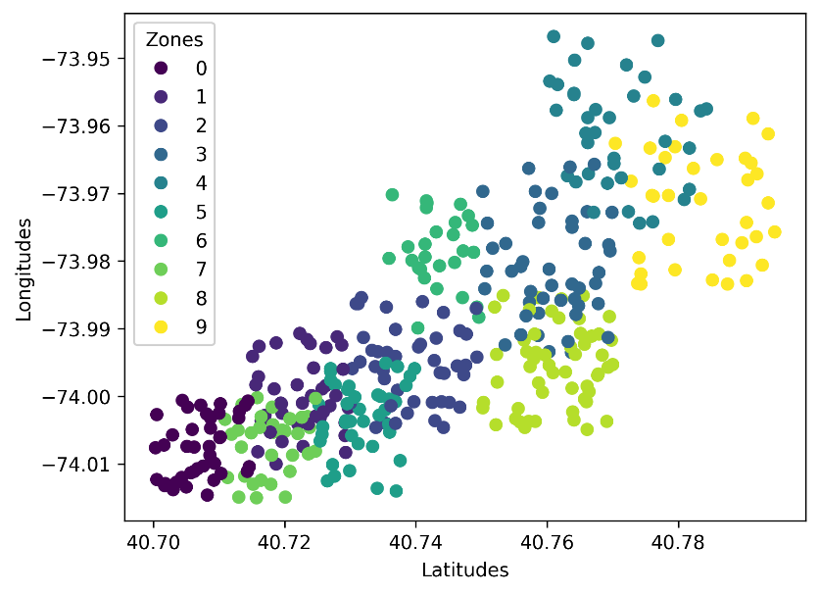
According to research methodology, we ran our scaled coordinates against each six clustering algorithms we chose with defined parameters and evaluated the clustering using internal and external metrics. Table 1 shows the results for internal metrics and Table 2 shows for external metrics. Figure 3 and 4 shows the plot of results of all the algorithms against all the evaluation metrics.
Clustering Method | Silhouette Score | Davies-Bouldin Index | Calinski-Harabasz Index
K-Means | 0.3450 | 0.9178 | 614.6980
Agglomerative | 0.3296 | 0.9479 | 587.6805
BIRCH | 0.3215 | 0.9567 | 542.4604
Mini-Batch KMeans | 0.3425 | 0.9068 | 575.5091
Spectral | 0.3065 | 0.8992 | 481.6825
Gaussian Mixture | 0.3353 | 0.9381 | 582.2758

Clustering Method | Rand index | Adjusted Rand Index | Mutual Information | Adjusted Mutual Information | Normalized Mutual Information | Fowlkes-Mallows Index | Homogeneity | Completeness | V-measure
K-Means | 0.8894 | 0.4124 | 1.4515 | 0.6220 | 0.6403 | 0.4745 | 0.6344 | 0.6464 | 0.6403
Agglomerative | 0.8955 | 0.4396 | 1.4550 | 0.6223 | 0.6406 | 0.4982 | 0.6360 | 0.6454 | 0.6406
BIRCH | 0.8914 | 0.4435 | 1.4680 | 0.6357 | 0.6537 | 0.5056 | 0.6416 | 0.6663 | 0.6537
Mini-Batch KMeans | 0.9047 | 0.4878 | 1.5207 | 0.6520 | 0.6688 | 0.5411 | 0.6647 | 0.6730 | 0.6688
Spectral | 0.8675 | 0.3668 | 1.3422 | 0.5894 | 0.6104 | 0.4450 | 0.5866 | 0.6361 | 0.6104
Gaussian Mixture | 0.8880 | 0.4194 | 1.4985 | 0.6485 | 0.6658 | 0.4830 | 0.6550 | 0.6771 | 0.6658

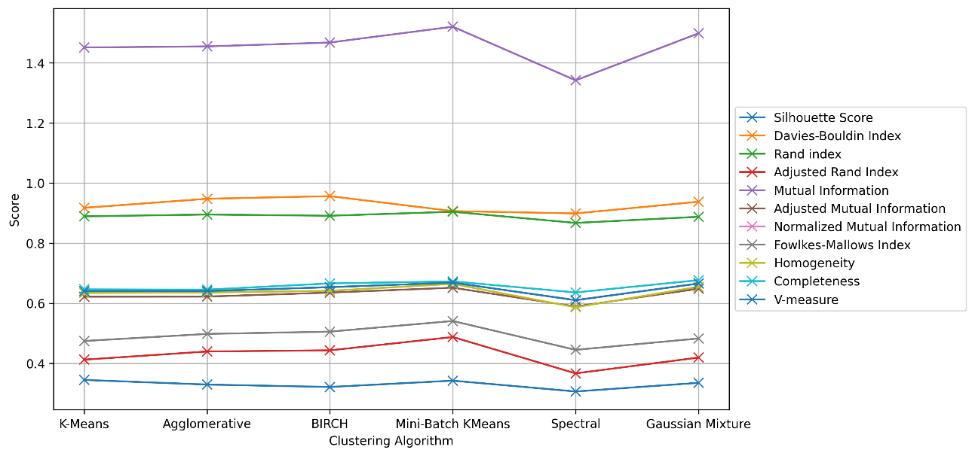
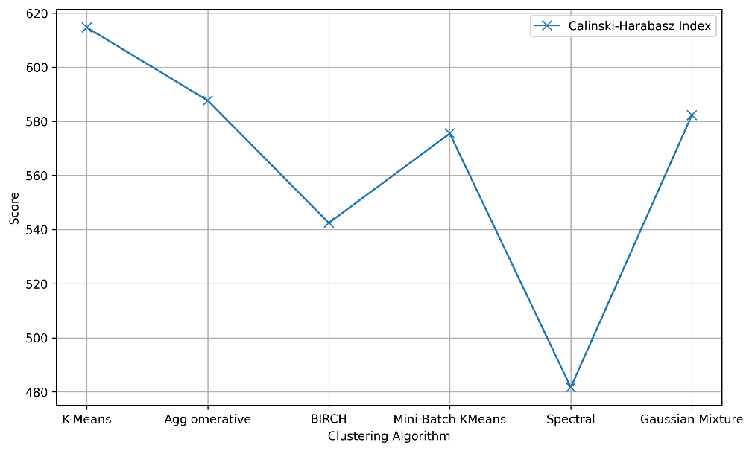

Discussion
Internal metrics evaluations show how each algorithm is handled from the results itself. K-Means algorithm has the highest silhouette score which is the best while Spectral has the lowest score. When evaluating Davies-Bouldin Index, Spectral has shown the lowest score which is the best, but BIRCH has shown the highest score which not ideal. K-Means has shown as the third best from this metric. For Calinski-Harabasz Index, K-Means has shown the highest score which is the ideal while Spectral has shown least score. From the results, we K-Means has performed well with internal metrics. Figure 5 shows how K-Means algorithm has clustered the delivery zones.
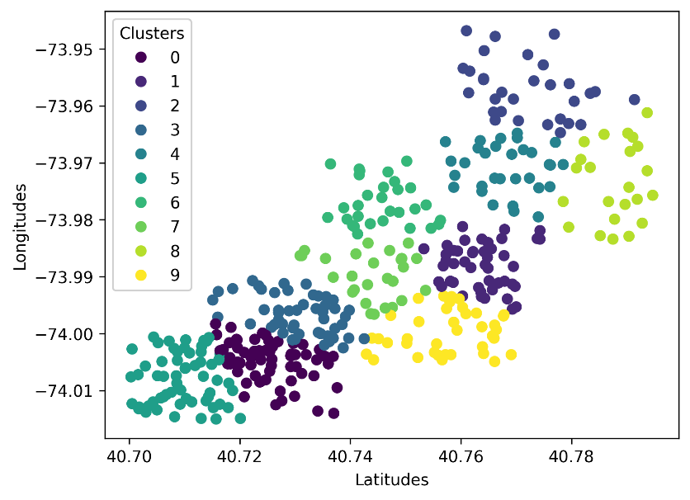
If we explain further, if a restaurant has not segregated their delivery area to zones on any condition and if they are doing it for the first time, K-Means Clustering is the most suitable algorithm for the task.
External metrics shows how well algorithm has segregated the zones compared to the real zones. For RI and ARI, Mini-Batch K-Means has the highest score while spectral algorithm has the lowest score. The only difference is Agglomerative has performed well in Rand Index compared to Adjusted Rand Index. For MI, AMI and NMI, Mini-Batch K-Means has the highest score while spectral has the lowest score. Scoring distribution is same for the three metrics but the value ranges has been changed. Fowlkes-Mallows Index shows the same results which makes Mini-Match K-Means ideal. Homogenity score shows in favour of Mini-Match K-Means while Completeness score shows in favour of Gaussian Mixture. Finally, V-Measure score states Mini-Match K-Means is the ideal.
Mini-Batch K-Means algorithm has performed well in external metrics. Figure 6 shows how Mini-Batch K-Means algorithm has clustered the delivery zones.
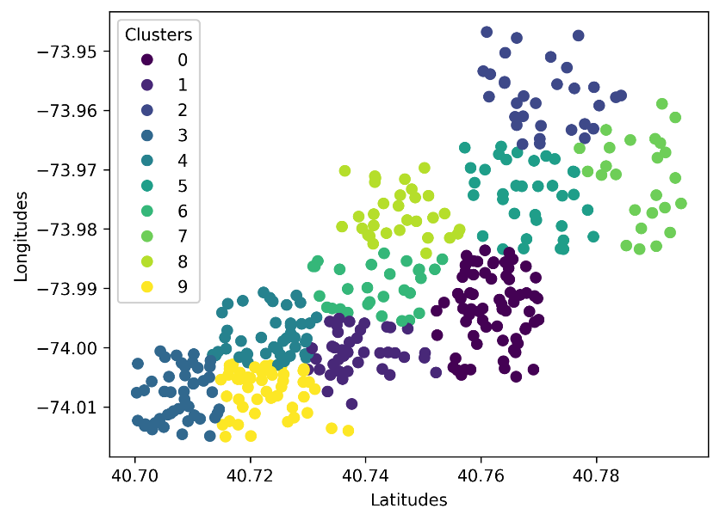
If a restaurant has zones in the delivery area already, they can use Mini-Batch K-Means Clustering as the algorithm and evaluate external metrics to check whether they have segregated the zones correctly. And they can even change the zones of the deliveries according to the output of the algorithm.

References
[1] B. Niu, Q. Li, Z. Mu, L. Chen, and P. Ji, “Platform logistics or self-logistics? Restaurants’ cooperation with online food-delivery platform considering profitability and sustainability,” Int J Prod Econ, vol. 234, Apr. 2021, doi: 10.1016/j.ijpe.2021.108064.
[2] M. R. Abdullahi, Q. C. Lu, A. Hussain, S. Tripura, P. C. Xu, and S. X. Wang, “Location optimization of EV charging stations: A custom K-means cluster algorithm approach,” Energy Reports, vol. 12, pp. 5367–5382, Dec. 2024, doi: 10.1016/j.egyr.2024.09.075.
[3] geeksforgeeks.org, “Clustering in Machine Learning,” geeksforgeeks.org. Accessed: May 11, 2025. [Online]. Available: https://www.geeksforgeeks.org/clustering-in-machine-learning/
[4] R. Vaish, U. D. Dwivedi, S. Tewari, and S. M. Tripathi, “Machine learning applications in power system fault diagnosis: Research advancements and perspectives,” Nov. 01, 2021, Elsevier Ltd. doi: 10.1016/j.engappai.2021.104504.
[5] C. M. Weber, D. Ray, A. A. Valverde, J. A. Clark, and K. S. Sharma, “Gaussian mixture model clustering algorithms for the analysis of high-precision mass measurements,” Nucl Instrum Methods Phys Res A, vol. 1027, Mar. 2022, doi: 10.1016/j.nima.2021.166299.
[6] L. W. Yerbury, R. J. G. B. Campello, G. C. Livingston, M. Goldsworthy, and L. O’Neil, “Comparing Clustering Approaches for Smart Meter Time Series: Investigating the Influence of Dataset Properties on Performance,” Dec. 2024, doi: 10.1016/j.apenergy.2025.125811.
[7] M. Jahanian, A. Karimi, N. O. Eraghi, and F. Zarafshan, “MedTransCluster: Transfer learning for deep medical image clustering,” Intell Based Med, vol. 9, Jan. 2024, doi: 10.1016/j.ibmed.2024.100139.
[8] G. Mirzaei and H. Adeli, “Machine learning techniques for diagnosis of alzheimer disease, mild cognitive disorder, and other types of dementia,” Feb. 01, 2022, Elsevier Ltd. doi: 10.1016/j.bspc.2021.103293.
[9] B. Sadeghi, “Clustering in geo-data science: Navigating uncertainty to select the most reliable method,” Jun. 01, 2025, Elsevier B.V. doi: 10.1016/j.oregeorev.2025.106591.
[10] E. Lim and H. Hwang, “The Selection of Vertiport Location for On-Demand Mobility and Its Application to Seoul Metro Area,” International Journal of Aeronautical and Space Sciences, vol. 20, no. 1, pp. 260–272, Mar. 2019, doi: 10.1007/s42405-018-0117-0.
[11] F. Pedregosa et al., “Scikit-learn: Machine Learning in Python,” 2011. [Online]. Available: http://jmlr.org/papers/v12/pedregosa11a.html

Appendix
Assume two label assignments (of the same N objects), $U$ and . Their entropy is the amount of uncertainty for a partition set, defined by:
$$H\left(U\right)=-\sum_{i=1}^{\left|U\right|}{P(i)\log{(P(i))}}$$
where $P(i) = \left|U_{i}\right|/N$ is the probability that an object picked at random from $U$ falls into class $U_{i}$. Likewise for V:
$$H\left(V\right)=-\sum_{j=1}^{\left|V\right|}{P(i)\log{(P(i))}}$$
$H(C|K)$ is the conditional entropy of the classes given the cluster assignments.
$$H\left(C | K\right)=-\sum_{c=1}^{\left|C\right|}{\sum_{k=1}^{\left|K\right|}{\frac{n_{c,k}}{n}×\left(\frac{n_{c,k}}{n_{k}}\right)}}$$
$$H\left(C\right)=-\sum_{c=1}^{\left|C\right|}{\frac{n_{c}}{n}×}\log\left(\frac{n_{c}}{n}\right)$$

